THE STATE EDUCATION DEPARTMENT / THE UNIVERSITY OF THE STATE OF NEW YORK
System to Track and Account for Children (STAC) and Medicaid Unit
Steven Wright, Director

89 Washington Avenue ● Room 25 EB ● Albany, NY 12234 Tel: (518) 474-7116 • FAX: (518) 402-5047
STAC E-mail: omsstac@nysed.gov Medicaid E-mail: medined@nysed.gov
STAC Website: http://www.oms.nysed.gov/stac Medicaid Website: http://www.oms.nysed.gov/medicaid

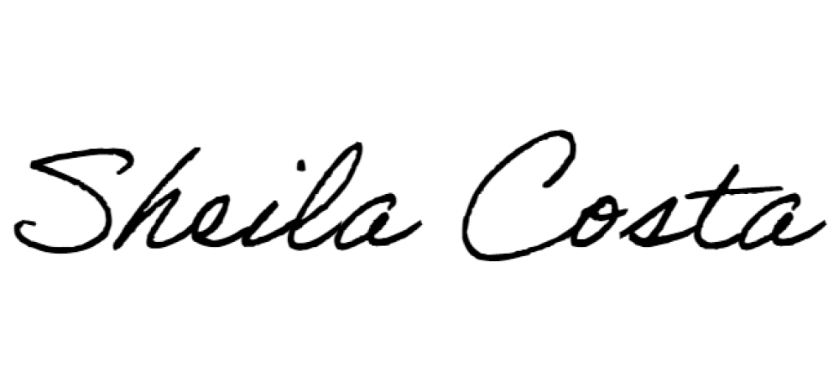
To: Preschool/School Supportive Health Services Program (SSHSP) Providers
From: Sheila Costa, Medicaid Coordinator
Date: June 2022

Subject: SSHSP Technical Support

New York State Education Department (NYSED) vendor contracts to provide regional technical support for the SSHSP will end June 30, 2022. Effective July 1, 2022, SSHSP technical support and assistance will be provided directly by the NYSED STAC/Medicaid Unit.
This technical support and assistance resource is intended to aid school districts and counties in accessing federal reimbursement for services provided to students with Medicaid coverage receiving certain medically necessary services as part of an Individualized Education Program.
The NYSED is your main resource for questions related to SSHSP policy. SSHSP documentation training reviews are included in this technical assistance. Other SSHSP trainings such as the Introduction to Medicaid (Medicaid 101) presentation will continue to be delivered by State program staff.
NYSED cannot assist with the use of SSHSP billing software utilized by your school district/ county for the submission of claiming data to NYS Medicaid, however, we will assist in identifying the appropriate resource(s) for resolution of billing/claiming issues.
As a reference, resources for participating SSHSP billing providers are included below. For questions regarding this memo, please contact us via email.
Thank you for your continued commitment to the SSHSP.

SSHSP Resources

SSHSP Provider Support and Training
NYS Education Department - Medicaid in Education
(518) 474-7116 / medined@nysed.gov

Medicaid Unit Staff
Sheila Costa – Medicaid Coordinator Paula Cooper
Tom Hitchcock Kelly Mason

SSHSP Medicaid Policy and Claiming
NYS Department of Health
(518) 473-2160 / SSHSP@health.ny.gov

SSHSP Guidance Documents (SSHSP Handbook, Medicaid Alerts, Q+As)

NYS SSHSP Training Calendar (Medicaid 101)

Mandatory Compliance Programs and OMIG Audits
NYS Office of the Medicaid Inspector General (518) 473-3782

Certified Public Expenditures and Random Moment Time Study
Public Consulting Group, Inc.
(866) 912-2974 / NYSSHSP@pcgus.com

eMedNY/ePACES
Enrollment, Affiliation, Revalidation, and Training
General Dynamics Information Technology (GDIT) – (eMedNY) (800) 343-9000
Payment/denial questions: Select #1-Billing, then #2-Clinic (SSHSP enrolled districts and
counties are considered clinics) - have payment or denial transaction control number (TCN) and your school district/county NPI#
Enrollment questions: Select #2-Enrollment and have your MMIS# (Medicaid #) and your NPI#

Billing/Claiming and Special Education Software and Systems
Contact your school district/county software vendor for assistance

